Firewall google account – emil - bhsautomationdatabasesystem@gmail.com
Pw – BHS@automation200500%>
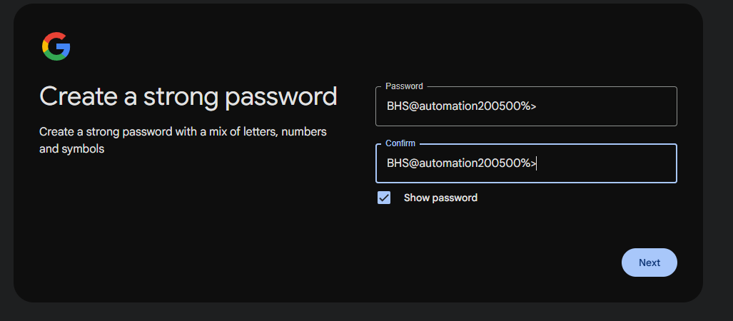

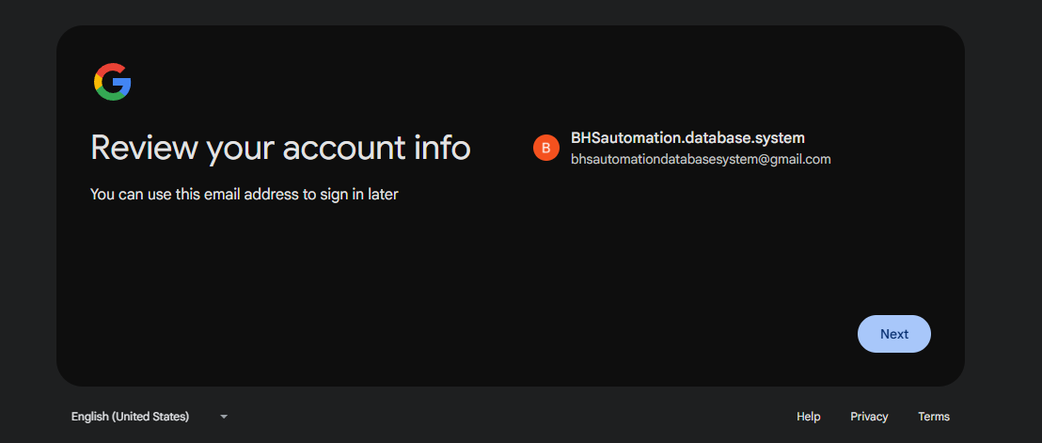
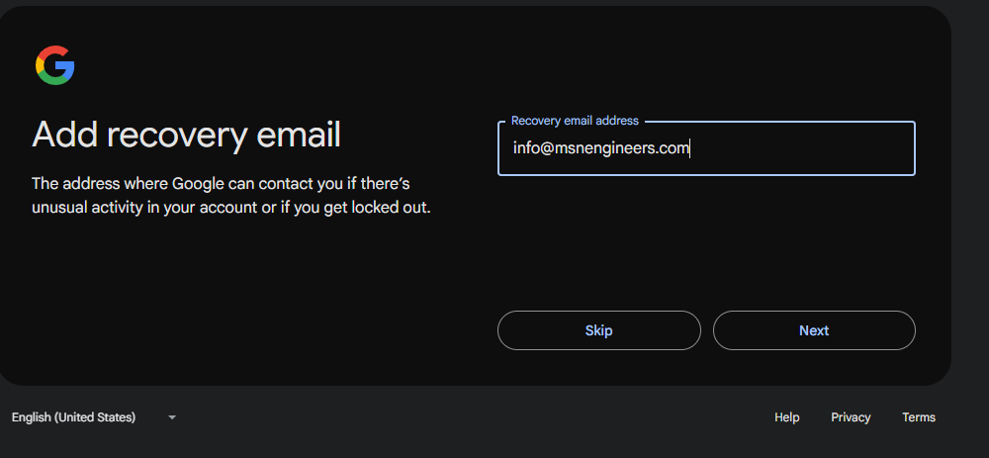

Sophos central account
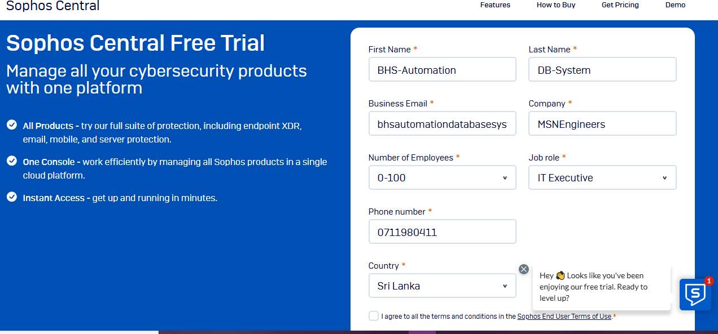

Pw Sophos central - HZ3isrhftmjU9p.
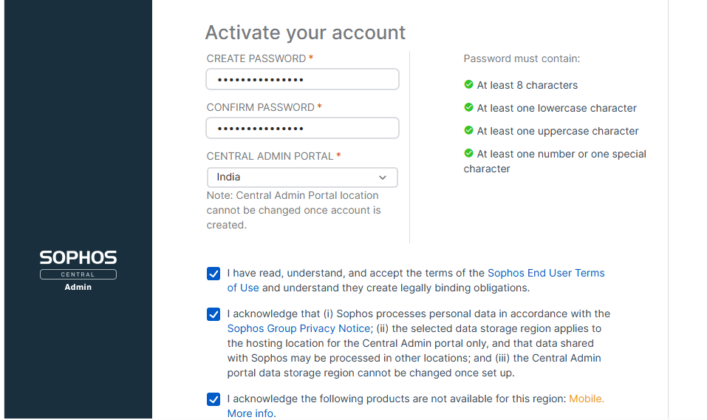
Admin setup – firewall
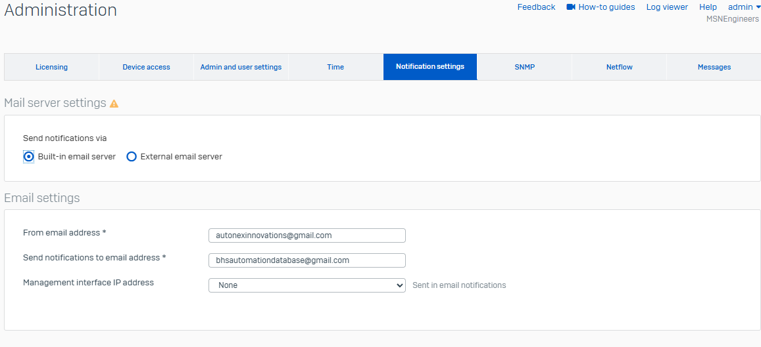

Firewall backup – pw for encryption – 200500LIshara
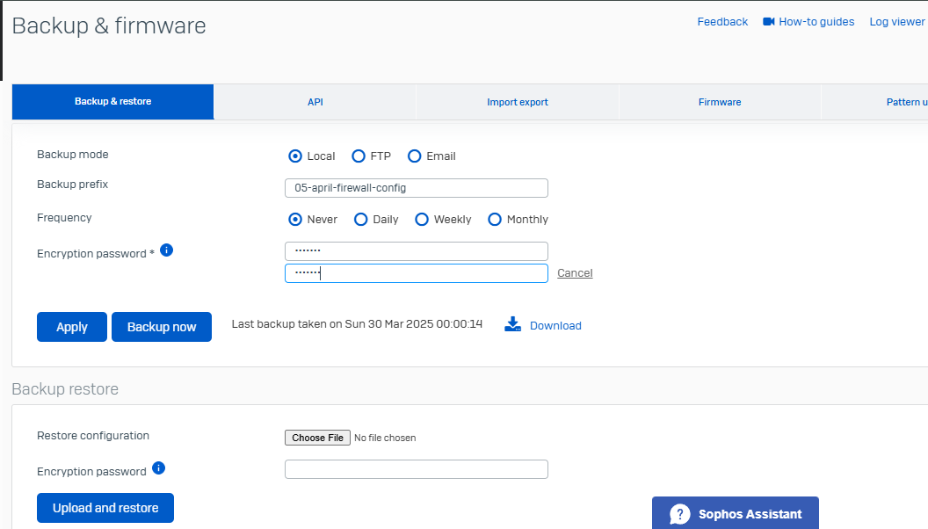

Free demo credentials – firewall
Uname – demo
Pw- XG@dem0user
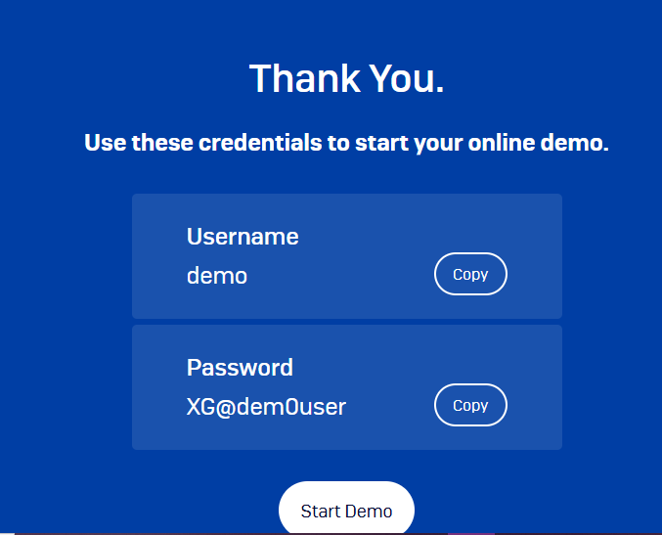

Firewall general user – username and name – BHSautomation
Pw – BHS500200#automation
